Big Mountain Resort Pricing Strategy Analysis Report

The current ticket price for an adult on weekend is $81 at Big Mountain Resort, and it’s simply determined by charging a premium on the average price in the market place. It is common to question whether the price and the way to set the price are good or not when there is no such a solid supporting reason behind it. Moreover, it’s hard to make a decision like whether to build additional facilities since what the impact on sales is and whether it could cover the costs are unclear. As a result, the company will probably suffer from decreased revenue due to inappropriate price and/or decision.

This modeling analysis is based on the assumption that people value certain facilities more than other ones and that other resorts in the market set their ticket price largely relying on this. For instance, we positioned Big Mountain Resort among all the resorts in the market place in terms of how many we have on each meaningful facility. With all information provided, we found that we are positioning very well in majority of the facilities, which means that we probably have a pretty strong support for a higher price.

We developed a RF model to find out the significant facilities associated with the price and to predict the optimal price based on the findings and the available facilities at Big Mountain Resort. Based on the developed model, we found that 4 facilities/features are more important than others in terms of having positive impact on price setting, which are numbers of fast quads, total runs, total snow making area (in acres), and vertical drop amount. The detailed list of top 10 facilities is presented in the below horizontal bar chart pic.

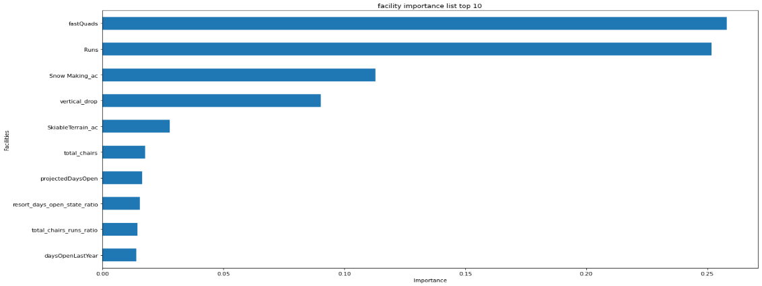

Also, we predicted that $95, more specifically $95.87 with expected mean absolute error of $10.39, is a price that is well supported by the available facilities in Big Mountain Resort based on the developed model. Moreover, with an estimated number of visitors of 350,000 and 5 days per visit for this season, setting the price at $95 will increase the ticket sales by $24,500,000.

Furthermore, we did the tests on the optional action scenarios and found that only scenario 2, that increasing the vertical drop by adding a run to a point 150 feet lower and an additional chair lift as needed for the change, is expecting to have a positive impact on the suggested price by almost $2 and the revenue by around $347,000,000. All other options are either has negative impact or do not have a significant impact, if any.

In conclusion, we suggest the ticket price for Big Mountain Resort to be $95 for the coming season based on the model prediction, which will lead to a $24,500,000 increase in revenue. The main justification is that people value certain facilities and willing to pay higher price than other facilities while in fact what Big Mountain Resort currently have is supporting the higher price we suggested.